ND530
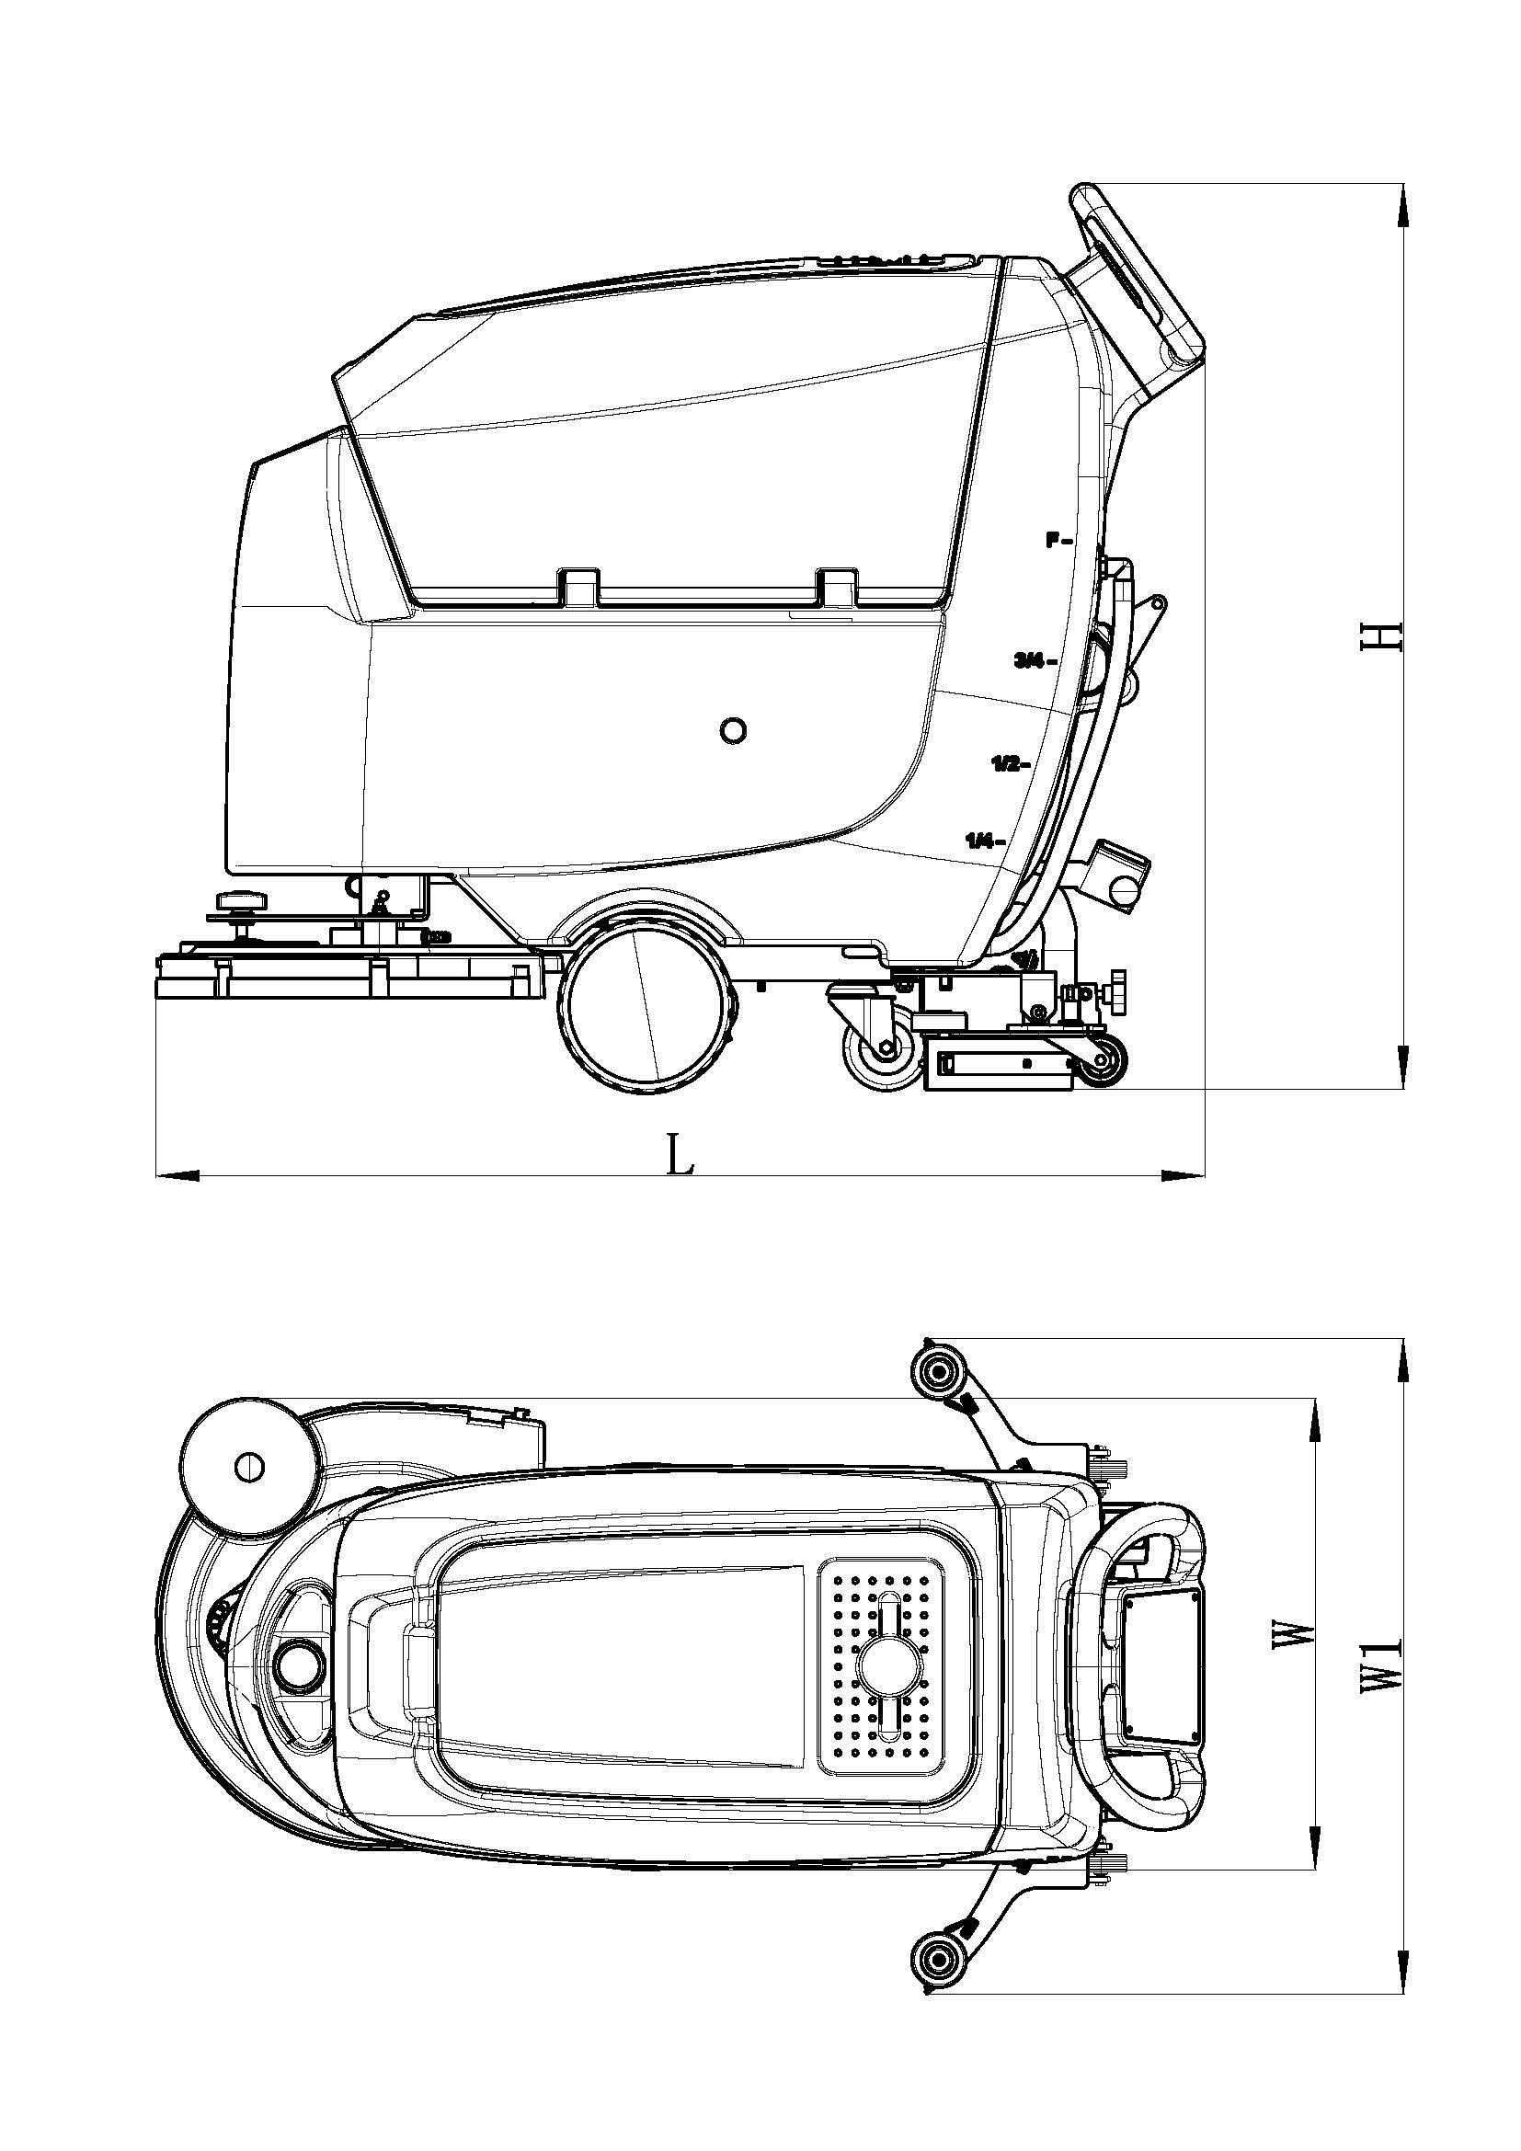

Cleaning vehicle parameter table
Manufacturer`s type designation |  | ND530
Drive |  | Battery
Operator type |  | Hand push
Service weight (Without battery) | Kg | 100
Wheel diameter | ∅ x w (mm) | (∅200×38)*2
Brush/ Pad diameter | ∅ x w (mm) | 530
Vehicle length | L(mm) | 1250
Vehicle width | W(mm) | 550
Squeegee width | W₁(mm) | 840
Vehicle height | H (mm) | 1050
Solution tank capacity | L | 50
Recovery tank capacity | L | 50
Cleaning path | mm | 530
Brush speed | Rpm | 180
Max. gradeability | % | 2
Brush pressure (without pressure device) | Kg | 20.5
Brush pressure (with pressure device) | Kg | 27.8
Drive motor rated power | W | 550
Vacuum motor rated power | W | 400
Vacuum capacity | KPa | >11
Sound pressure level | dB (A) | 65.8±3
Battery voltage | V/Ah | 24/100
Battery size (L x W x H) (mm) | mm | 350x350x300

