Version 02/2025
ND530-SMS-001-EN
xyz
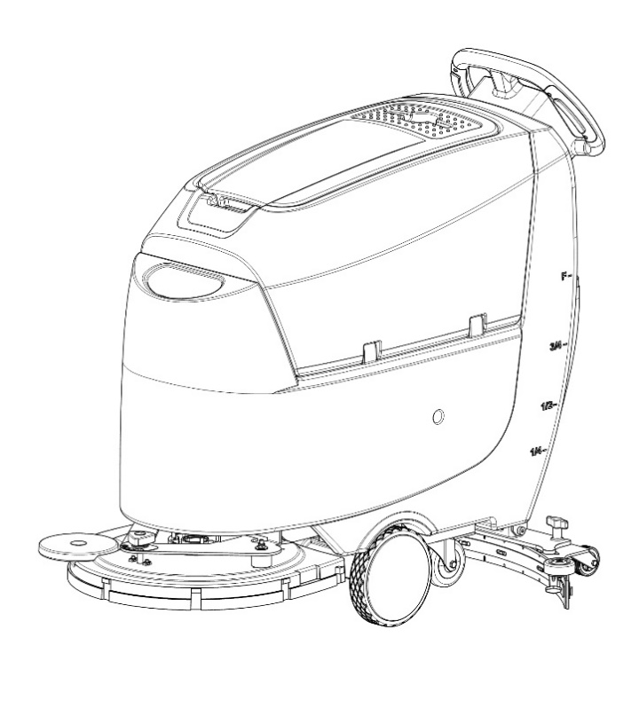
WARNING
Do not use the scrubber before reading and understanding these operating instructions.
NOTE:
- Please check the designation of your present type at the last page of this document as well as on the ID-plate.
- Keep this manual for future reference.

Operator Manual
ND530 Walk-Behind Floor Scrubber with Driver
CONTENTS
Introduction 2
Intended Use 2
How to Keep this Manual 2
Declaration of Conformity 2
Accessories and Maintenance 2
Change and Improvement 3
Machine Identification 3
Transport and Uncrating 3
Reading Guide 3
Safety 4
Important Safety Instructions 4
Know your Machine 7
Overview of Appearance 7
Button Function 8
Operation 9
Installing and Removing Disk Brushes/Pads 9
Install Squeegee Assembly 10
Solution Tank Filling 10
Start and Stop of Machine 10
Draining Tanks 11
After Use 11
After Long-Term Inactivity 11
Initial Use 12
Maintenance 13
Regular Maintenance Checklist 13
Charging Battery 13
Cleaning Squeegee 13
Cleaning Brush/Pad 14
Troubleshooting 15
Fault Code 15
Scrapping and Dispose 17
Specifications 18
Lithium Battery 20


Introduction
CAUTION
- This manual is to provide the operator with the necessary information for the correct and safe use of the machine, which includes the technical data, safety, operation, storage, maintenance, accessories and dispose of the machine.
- Before performing any operation or maintenance on this machine, the operator and the qualified technicians must read this manual carefully.
- If you have any questions about the explanation of this manual or want more related information, please contact our after-sales or agency.
- The operator is not allowed to perform the steps that must be completed by the technicians. All instructions in this manual should be seriously followed, otherwise our company shall not be liable for any losses arising therefrom.

Intended Use
This floor scrubber can be used in commercial and industrial environments, and it is suitable for cleaning smooth and hard floors (washing and sewage collecting). It must be used in a safe environment by a qualified operator. This scrubber is not suitable for cleaning outdoors floors, carpets or rough floors.

How to Keep this Manual
- The Manual must be kept near the machine, inside an adequate case or bag, away from liquids and other substances that can cause any damage to it.

Declaration of Conformity
- The declaration of conformity is provided with the machine to prove that the machine complies with relevant criteria and regulations.

Accessories and Maintenance
- All necessary operation, maintenance and repair procedures must be performed by qualified personnel or the maintenance center designated by our company. Only original spare parts and accessories are allowed to be used on the machine.
- If you need service or want to order spare parts or accessories, please contact our company's after-sales service department or the agent, and provide the model and serial number of the machine.

Change and Improvement
- Our company is committed to the continuous improvement of the products and reserves the right to notify the improvements and changes of the products that have been sold.

Machine Identification
- The model and serial number of this machine are marked on the identification label. The information on this label is very important, which is required to be provided when you order the accessories for the machine.

Transport and Uncrating
- Carefully check machine for signs of damage. Report damages at once to carrier. Record the damages on paper to reserve the right for compensation.
After uncrating, check if the machine is equipped with the following items:
- Technical documents, including operation manual;
- Battery connecting cable.

Reading Guide
The following symbols and terms are used throughout this manual to alert the reader to safety issues and important information:

SYMBOL | TERM | EXPLANATION
 | DANGER | It indicates the danger that may cause death of the operator.
 | WARNING | It indicates a potential hazard of injury to people and objects.
 | ATTENTION | It indicates a caution related to important or useful functions.  Pay attention to the paragraphs marked by this symbol.
 | NOTE | It indicates notes on important matters and useful functions.
 | CONSULTATION | It indicates the necessity to refer to the instructions of this manual before performing any procedures.

Safety

Important Safety Instructions
Save These Instructions

FOR SAFETY: To identify actions which must be followed for safe operation of equipment.

WARNING:
- Disconnect the battery before performing any maintenance/repair procedures.
- Only trained or authorized personnel is allowed to use this machine. Children or disabled people cannot use this machine.
- Keep the battery far from sparks, flames and incandescent material. During the normal operation explosive gases are released.
- Do not wear jewelry when working near electrical components.
- Do not work on the ground that cannot bear the weight of the machine.
- Do not use the machine near toxic, dangerous, flammable, explosive dust, liquid, or steam.
- The battery will produce explosive hydrogen during the charging process. Please keep the recovery tank open during charging, and ensure that the surrounding area is well ventilated and away from open flames.
WARNING:
- This machine is intended for COMMERCIAL USE, for example in hotels, schools, hospitals, factories, shops, offices and rental businesses.
- Machines left unattended shall be secured against unintentional movement.
- In order to prevent unauthorized use of the machine, the power source shall be switched off or locked, for example by removing the key of the main switch or the ignition key.
- Check the machine carefully before each use. Ensure that all the components have been well assembled before use. Or it may cause damages to people and properties.
- Before using the battery charger, ensure that the values of frequency and voltage indicated on the machine serial number label match those of mains.
- Never move the machine by pulling the battery charger cable. Do not let the cable through a closed door, or winding on sharp edges or corners.
- Do not run the machine on the battery charger cable.
- Keep the battery charger cable away from heated surfaces.
- Do not charge the batteries if the battery charger cable or the plug are damaged.
- To reduce the risk of fire, electric shock, or injury, make sure machine is off before leaving.
- Use or store the machine indoors in dry conditions, it is not allowed for outdoor use.
- The machine both storage and working temperature must be between 0 °C and +40 °C, the humidity of air must be between 30% - 95%.
- Do not use the machine on slopes with a gradient exceeding as specification show.
- When using and handling floor cleaning detergents, follow the instructions on the labels of the detergent bottles and wear suitable gloves and protections.
- Use brushes and pads supplied with the machine or defined in the manual. Using other brushes or pads could reduce safety.
- In case of machine malfunctions, ensure that these are not due to lack of maintenance. If necessary, request assistance from the authorized personnel or from an authorized Service Center.
- Take all necessary precautions to prevent hair, jewels and loose clothes from being caught by the machine moving parts.
- Do not use the machine in particularly dusty areas.
- Do not wash the machine with direct or pressured water jets, or with corrosive substances.
- Do not bump into shelves or scaffoldings, especially where there is a risk of falling objects.
- Do not lean liquid containers on the machine, use the relevant can holder.
- To avoid damaging the floor, do not allow the brush/pad to operate while the machine is stationary.
- In case of fire, use a dry powder fire extinguisher. Do not use liquid fire extinguishers.
- Do not remove or modify the machine stickers.
- Do not tamper with the machine safety guards and follow the ordinary maintenance instructions scrupulously.
- Pay attention during machine transportation when temperature is below freezing point. The water in the recovery tank and in the hoses could freeze and cause seriously damage to the machine.
- If spare parts need be replaced, order ORIGINAL spare parts from an Authorized Dealers or Retailers.
- Return the machine to the Service Center if it doesn’t work as usual or is in condition such as damaged, placed outdoors, dropped into water.

Know your Machine

Overview of Appearance
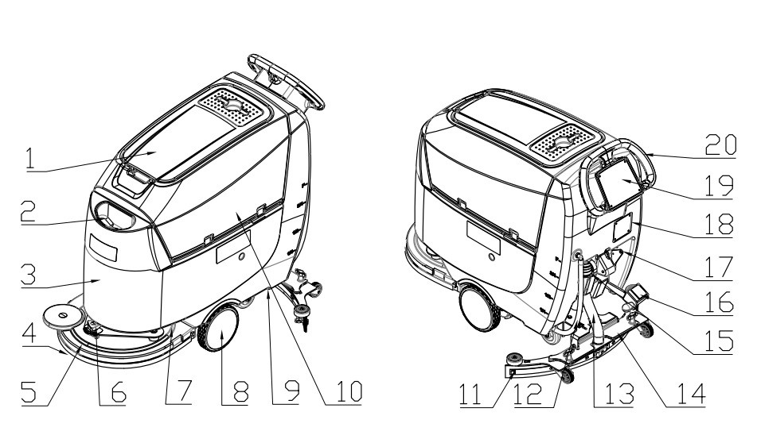

- RECOVERY TANK COVER
- SOLUTION TANK FILL-PORT
- SOLUTION TANK
- BRUSH/PAD
- BRUSH DECK
- BALANCE ADJUSTING KNOB
- ELECTRIC VALVE
- WHEEL
- WATER TAP
- RECOVERY TANK
- SQUEEGEE
- SOLUTION TANK LEVEL HOSE
- VACUUM HOSE
- HOLDER FOR SQUEEGEE
- DRAIN HOSE
- LIFT FOOT PEDAL
- LIFTING LEVEL
- CHARGE CONNECTOR
- SCREEN DISPLAY
- OPERATORING HANDLEBAR

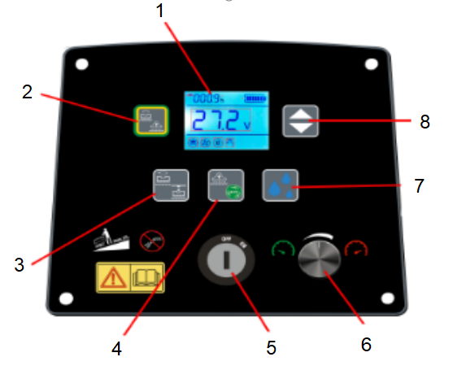
Button Function

- SCREEN DISPLAY
- ONE KEY START
- BRUSH BUTTON/BRUSH REMOVAL BUTTON (PUSH THREE SECONDS)
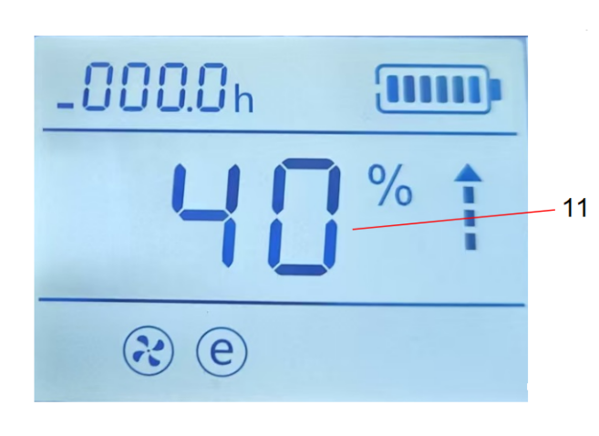
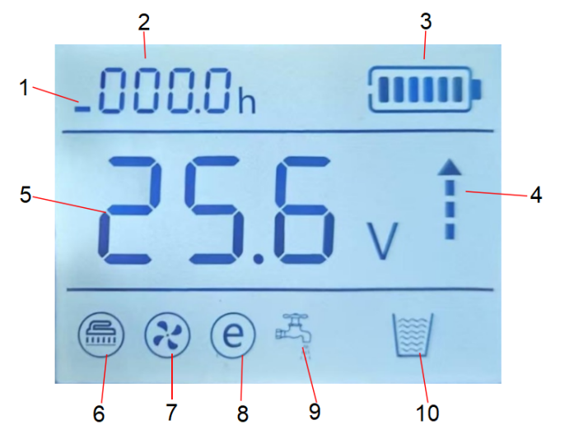
- VACUUM BUTTON/ECO MODE
(PUSH THREE SECONDS)
- KEY SWITCH
- SPEED ADJUSTING BUTTON
- SOLUTION FLOW BUTTON
- FORWARD/BACKWARD BUTTON

- TOP: MACHINE WORKING TIME
MIDDLE: BRUSH WORKING TIME
BOTTOM: VACUUM WORING TIME
- WORKING TIME
- BATTERY LEVEL
- FORWARD/BACKWARD DISPLAY
- BATTERY VOLTAGE
- BRUSH STATUS (ICON WILL BE FLICKE WHEN KEY SWITCH BRUSH MOTOR ABNORMAL)
- VACUUM MOTOR STATUS (ICON WILL BE FLICKE WHEN VACUUM MOTOR ABNORMAL)
- ECO MODE
- SOLUTION FLOW STATUS
- RECOVERY TANK FULL(SELECT)
- SOLUTION FLOW/SPEED LEVEL
(0%,40%,70%,100% FOUR LEVEL)

Operation
The main purpose of this chapter is to provide the necessary operating instructions for the operators.
Note: Charge the battery pack when it is correctly connected in the machine. Make sure the battery pack is charged monthly.
WARNING:
If the battery is installed or wired incorrectly, the electrical components of the machine may be seriously damaged. The battery must be installed by qualified personnel. Please check whether the battery is damaged before assembling. Disconnect the battery connector and charger plug. Handle the battery with great care. This machine requires two 12V batteries, please follow the solution water tank drawing for wiring.

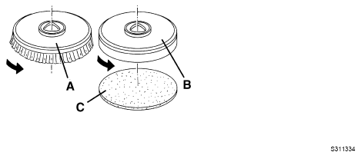
Installing and Removing Disk Brushes/Pads
- The machine can be equipped with brush or pad depending on the different cleaning tasks.
- Place the brush disk (A) or pad driver (B) under the holder.
- Operate the squeegee lower/lift foot pedal to lower the holder for installing the brush/pad driver.
- Start the machine through turning the key switch to "ON" position.
- Turn on the brush button and walk switch to make brush motor running.
- Gently push the machine forward to install the brush disk/pad driver. If necessary, repeat this operation until the brush disk/pad driver is installed.
- Depress the foot pedal to lift the holder in order to remove the brush disk/pad driver, and then press and hold the bush switch until three seconds, and the brush disk/pad driver will fall to the ground automatically.
- If you need to remove the brush manually, just rotate the brush disk/pad driver in the opposite direction to the normal direction.

Install Squeegee Assembly
Install the squeegee assembly and tighten it with the squeegee fixing knob, and then assemble the vacuum hose to the squeegee.

Solution Tank Filling
- Fill the cleaning water or detergent suitable for floor by hose.
- The solution tank water level indicator on the side can be used to check the water capacity in the solution tank.
- The temperature of the filling water or detergent shall not exceed +104F (+40°C).
WARNING:
Use only low-foam and non-flammable detergents, which should be suitable for the use of floor washer.

Start and Stop of Machine
START THE MACHINE:
- Follow the methods described above for preparation.
- Turn on the key switch to "I" position. If the battery level isn’t enough through the screen, please turn the key switch to "O" position and charge the battery.
- Use the lifting lever to lower the squeegee
- Press the lift foot pedal to place the brush disk/pad driver on the ground.
- Press the one start key or brush and vacuum button, the brush and vacuum motor indicator will be on.
- Press the solution flow button to adjust the water flow according to the state of the ground to be cleaned.
- Press the speed button to select the speed of drive motor. Then press the walk button to drive the machine scrubbing.
- Adjusting the balance knob makes the machine walk straightly.
- Adjust the rear wheel of squeegee until the rear squeegee blade fully touches the ground, and the front squeegee blade must be in light contact with the ground.

STOP THE MACHINE:
- Release the walk switch to turn off the drive motor.
- Press the one start key or brush and vacuum button, the brush and vacuum motor indicator will be off.
- When the brush and vacuum motor turns off, depress the foot pedal to raise the brush disk/ pad driver.
- Lift the squeegee with the lifting lever.
- Turn the key switch to "O" position.
- Make sure that the machine cannot move independently.
WARNING:
- To avoid any damage to the floor surface, turn off the brush/pad motor when the machine stops in an area.
- Do not use the machine when the battery charge is low, to avoid damaging the batteries and reducing the battery life.

Draining Tanks
The sensor of recovery tank full will action when the recovery tank is full. The vacuum motor stop. operator need press vacuum motor button to close the vacuum motor. Then empty the recovery tank by drain hose.
When the recovery water tank is full, drain it according to the following procedures.
DRAINING RECOVERY TANK
- Stop the machine.
- Depress the foot pedal to raise the brush disk/ pad.
- Lift the squeegee by the lifting lever.
- Move the machine to the designated sewage discharge area.
- Drain the recovery tank through the drain hose.
DRAINING SOLUTION TANK
Empty the solution tank by solution tank level hose. Then rinse the tank with clean water.

After Use
After working, complete the following steps before leaving the machine:
- Remove the brush disk/pad according to the procedures shown in the relevant chapter.
- Drain the solution tank and recovery tank according to the procedures shown in the relevant chapter.
- Perform the daily maintenance procedures (see the maintenance chapter).
- Store the machine in a clean and dry place, with the brush disk/ pad driver and the squeegee lifted or removed.

After Long-Term Inactivity
If the machine is not going to be used for more than 30 days, proceed as follows:
- Perform the procedures shown in chapter of After Use.
- Disconnect the battery and the machine.
- Charge the battery regularly.

Initial Use
After the first 8 hours of use, check if the fastening and connecting parts of the machine are loose, and check for visible damage and leakage.

Maintenance
The service life and maximum operational safety of the machine are guaranteed by correct and regular maintenance. The following checklist provides a general maintenance schedule for the machine. The maintenance interval depends on the working condition of the machine, which should be set by the person in charge of maintenance.

WARNING:
The procedures must be carried out with the machine off and the battery disconnected. Moreover, read carefully the instructions in the Safety chapter before performing any maintenance procedures.
All regular or extraordinary maintenance procedures must be performed by qualified personnel, or by an authorized service center. This manual describes only the easiest and most common maintenance procedures. For other maintenance procedures shown in the Regular Maintenance Table, refer to the Service Manual that can be consulted at any service center.

Regular Maintenance Checklist
Check Item | Daily (after use) | Weekly | Semiannually
Charge battery
Clean squeegee
Clean brush/pad
Clean solution tank and recovery tank
Check seal of tanks
Check squeegee and replace it if necessary
Clean solution tank filter
Clean vacuum motor filter
Check if all screws and nuts are tightened

Charging Battery
WARNING:
1. Do not turn on the key switch or operate the machine while charging the battery.
2. Use battery charging connector insert into connector of machine charging (Fig1.18). then connect the power plug of battery charging.

Cleaning Squeegee
Note: The squeegee must be clean and its blades must be in good conditions in order to get a good drying.

WARNING:
It is advisable to wear protective gloves when cleaning the squeegee because there may be sharp debris.
- Move the machine to a level ground.
- Lift the squeegee by the lifting lever.
- Loosen the fixing knob, and remove the squeegee.
- Remove the vacuum hose from the squeegee.
- Clean the squeegee. In particular, clean the compartments and the vacuum hose from dirt and debris.
- Check the front squeegee blade and the rear squeegee blade for integrity, cuts and tears; otherwise replace them (see the procedures in the following paragraph).
- Assemble the squeegee in the reverse order of the above.

Cleaning Brush/Pad
WARNING:
It is advisable to wear protective gloves when cleaning the brush/pad because there may be sharp debris.
- Remove the brush disk/ pad from the machine according to the methods described above.
- Clean the brush disk/ pad with water and detergent.
- Check the brush bristles for integrity and wear, and replace the brush if necessary.
- Check the pad for wear, and replace the pad if necessary.

Clean the recovery tank and the filter, inspect the sealing of the lid.
- Remove the recovery tank lid and rinse the lid.
- Clean the recovery tank and the screen with clean water. Drain the sewage through the hose.
- If necessary, loosen the buckle of the screen, clean the float ball and other parts and fit them back.
- Check the sealing of recovery tank lid for integrity. Replace the sealing if necessary.

Troubleshooting
Trouble | Possible Cause | Remedy
Insufficient recovery water vacuuming | The recovery tank is full. | Drain the tank.
Insufficient recovery water vacuuming | The hose is disconnected from the squeegee. | Connect the hose and the squeegee.
Insufficient recovery water vacuuming | The float shut-off screen is clogged. | Clean the float shut-off screen and check the float.
Insufficient recovery water vacuuming | The hose or the inspiratory path is closed. | Clean the hose or the inspiratory path.
Insufficient recovery water vacuuming | The squeegee is dirty or the blades are worn or damaged. | Clean and check the squeegee.
Insufficient recovery water vacuuming | The recovery tank lid is not correctly closed or the sealing is broken. | Close the lid correctly or replace the sealing.
Insufficient solution flow to the brush | The solution/clean water filter is dirty and clogged. | Clean the filter.
Insufficient solution flow to the brush | The dirty solution tank makes the drain hose and tap clogged. | Clean the solution tank and the drain tap.
Insufficient solution flow to the brush | The electromagnetic valve is damaged or clogged. | Clean or replace the electromagnetic valve.
Marks caused by the squeegee | There are debris under the squeegee blade. | Remove the debris.
Marks caused by the squeegee | The squeegee blade is worn, shipped or torn. | Replace the squeegee blade.
Marks caused by the squeegee | The squeegee has not been balanced with the adjusting rear wheel of the squeegee. | Adjust the balance of the squeegee.

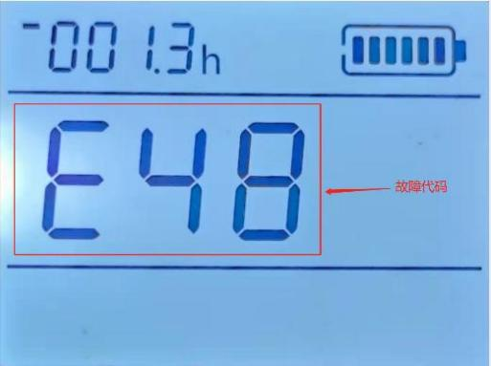
Fault Code
Fault code

When the machine fault by electrical fault. the screen display shows the fault code. The fault code as below.

Code No | Description | Root cause | Solution
E[01] | Pre-Charge fault1 | Motor MOS fault | Replace controller
E[03] | PVDD1 over-voltage | Over Voltage
E[04] | PVDD1 under-voltage | Under Voltage
E[07] | 12V-CPU over-voltage | CPU over-voltage
E[08] | 12V-CPU under-voltage | CPU under-voltage
E[12] | Key switch over-voltage | Over Voltage in key switch
E[13] | Key switch under-voltage | Under Voltage in key switch
E[14][16] | Battery under-voltage | Battery under-voltage
E[15][17] | Battery over-voltage | Battery over-voltage
E[25][26] | UART voltage fault | Controller fault | Replace controller
E[29] | Relay fault
E[30][31][32][33] | Motor NTC fault | Controller fault | Replace controller
E[34][35][36][37] | Drive motor high temperature | Drive motor high temperature | Check brush motor and connection
E[38][39] | Brush motor high temperature | Brush motor high temperature | Check brush motor and connection
E[3A][40] | Vacuum motor high temperature | Vacuum motor high temperature | Check vacuum motor and connection
E[41][43] | Drive motor MOS over-voltage | Dis-assemble the drive motor. The fault still happens. It is controller fault. Otherwise, it is driving motor fault. | Replace the drive motor or controller
E[42][44] | Drive motor MOS under-voltage |  | Replace the drive motor or controller
E[45] | Brush motor MOS over-voltage | Dis-assemble the brush motor. the fault still happens. It is controller fault. Otherwise, it is brush motor fault. | Replace the brush motor or controller
E[46] | Brush motor MOS under-voltage |  | Replace the brush motor or controller
E[47] | Vacuum motor MOS over-voltage | Dis-assemble the vacuum motor. the fault still happens. It is controller fault. Otherwise, it is vacuum motor fault. | Replace the vacuum motor or controller
E[48] | Vacuum motor MOS under-voltage |  | Replace the vacuum motor or controller
E[63] | Drive motor open-circuit | Check carbon brush of drive motor and wires. | Replace the drive motor or wire.
E[64][65] | Drive motor short-circuit | Check brush motor and wires. | Replace the brush motor or wire.
E[66] | Drive motor over-current | The current of drive motor more than the setting of the controller. | Check the drive motor or wire.
E[67] | Brush motor open-circuit | Check carbon brush of brush motor and wires. | Replace the brush motor or wire.
E[68] | Brush motor short-circuit | Check brush motor and wires. | Replace the brush motor or wire.
E[69] | Brush motor over-current | The current of brush motor more than the setting of the controller. | Check the ground roughness, brush motor and wire.
E[6A] | Vacuum motor open-circuit | Check carbon brush of vacuum motor and wires. | Replace the vacuum motor or wire.
E[70] | Vacuum motor short-circuit | Check vacuum motor and wires. | Replace the vacuum motor or wire.
E[71] | Vacuum motor over-current | The current of vacuum motor more than the setting of the controller. | Check the vacuum motor or wire.

Scrapping and Dispose
Have the machine scrapped by a qualified scrapper.
Before scrapping the machine, remove and separate the following materials, which must be properly disposed of according to relevant laws and regulations:
– Battery
– Brush disk/pad driver
– Plastic hoses and components
– Electrical and electronic components (*)

Specifications
ND530 Specifications
Model | ND530
Machine Height | 1050mm
Solution tank capacity | 50 L
Recovery tank capacity | 50 L
Front wheel diameter | 200mm
Rear wheel diameter | 100mm
Vacuum motor power | 400w
Gradeability | 2%
Sound pressure level | 65.8±3dB(A)
Battery (maintenance free AGM) | (2x12V) 24V 100Ah
Battery compartment size (L*W*H) | 350x350x300mm
Vacuum capacity | >11Kpa
Scrubbing path width | 530mm
Squeegee width | 840mm
Maximum length | 1250mm
Machine width (without squeegee) | 550mm
Brush/pad diameter | 530mm
Net weight (without batteries) | 100kg
Brush motor rated power | 550W
Brush rotate speed | 180rpm
Minimum brush pressure | 20.5kg
Maximum brush pressure | 27.8kg

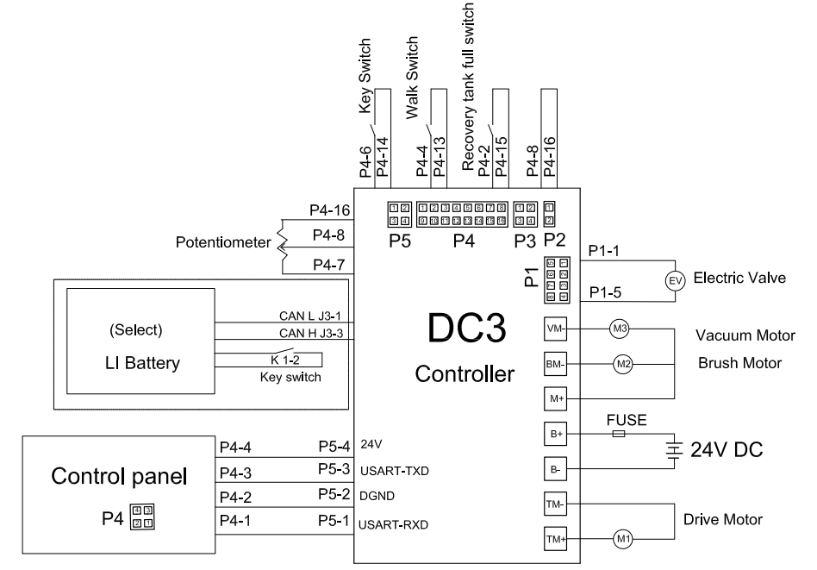
Electrical Wiring Diagram
P-14

Lithium Battery
Temperature range for using the battery is from +5°C to +40°C. Low temperatures reduce the effective battery capacity, high temperatures reduce the battery’s life time. The temperature difference between the two sides of the battery shall not exceed 5°C.
Only approved battery chargers must be used to charge the lithium battery.
Do not try to make any repairs or servicing of lithium batteries. Replacement of parts is not assumed.

Risk of electric shock and burning
The battery’s charging and discharging connectors have open terminals, avoid any body contacts, contamination or direct contacts with objects which can cause short circuit connection of terminals. Use necessary pre-cautions and protective caps to secure the open terminals. The connectors should be maintained in clean and dry conditions.

Use only batteries designed and approved by the manufacturer for the truck.
Do not try to modify or alter the battery.

Any damage or defects to the charger can result in accidents. Use only charger approved by the manufacturer of the truck, which is suitable for used battery.
In case charger has any damages or defects, exclude the charger from operation and contact your service provider. Do not modify or try to repair the charger.

Improper use of charger or use of wrong charger can cause damages to a battery or charger. Follow the required charger specifications; If the operation voltage of the charger is out of the applicable voltage range, the charger or battery may be damaged causing serious safety risks. The charger in use must be approved by the battery (truck) manufacturer.
Reversed connection of charging plug is prohibited. Follow the instruction for correct connection. For disconnection of charging plug use dedicated grip and never pull out the plug by means of cable.
Stop charging immediately if any abnormalities are detected, e.g. severe temperature increase, deformation of battery case, smoke, noise etc.

Intermediate charging
Lithium batteries support so called opportunity charging. The lithium battery, which is not fully discharged can be charged in any time. However, frequent opportunity charging not to the full charging state and stop of charging process before the appearance of corresponding indication of charger may result in dis-balance voltage of cells which increases the battery BMS calculation error. In order to effectively deal with this phenomenon, charge the battery in full allowing the automotive balancing process to be completed at least once a week.

Do not charge a fully charged battery
Note that in order to prevent the battery from continuing restart of charging under fully charged condition causing reduction of battery lifetime, the BMS has a protection function that prohibits recharging of fully charged battery.

Potential hazards
If equipment is used according to its design purpose, following the correct operations procedures, there are no hazards anticipated.

The following hazards can arise in the event of improper use:
- Physical damage to the battery in case a battery falls or is deformed through impacts. Mechanical damages can cause leakages of harmful materials, fire or battery explosion.
- Short circuits may be caused by short connection of battery terminals, for instance, by water or other intentional/unintentional short connections.
- Temperature damages caused by placing of batteries in overheated environment conditions or being exposed to impact of fire, open sunlight etc. can cause leakages of harmful materials, fire or battery explosion.

In order to avoid fire, explosion and/or leakage of harmful materials, a safe place for storing non-functional or damaged batteries until the service arrives on site must satisfy the following criteria:
- Do not store in places where personnel is located.
- Do not store in places with valuable objects and close to valuable objects.
- A Class D fire extinguisher must be available on demand.
- There should not be any fire or smoke detectors in the storage area in order to ensure that an automatic fire detection system is only activated in the event of actual danger (e.g. flames).
- No ventilation intake pipes should be in the facility to exclude spreading of discharged content within a building.

Examples of where to store a non-functional battery:
- Roofed outdoor position.
- Ventilated container.
- Covered fire resistant box with pressure and smoke discharge option.
Symbols - Safety and Warnings
 | Used lithium-ion batteries must be treated as hazardous waste.  Lithium-ion batteries marked with the recycling symbol and the sign showing a crossed-out waste bin must not be disposed of with ordinary household waste.
 | Avoid fire and short circuits causing overheating.  Do not ignite or locate batteries close to open flame, heat sources or sparks.  Keep lithium-ion batteries away from heat sources.
 | Caution!  Battery short-circuit is prohibited.
 | Protect the lithium-ion battery from solar radiation or other forms of heat radiation.  Do not expose the lithium-ion battery to heat sources.

Explosion and fire hazard
Physical damage, thermal impacts or incorrect storage in the event of a defect can result in explosions or fire. The battery materials can be flammable.

Particular hazard from combustion products
The lithium batteries may be damaged by a fire. When extinguishing a lithium battery fire, the following information must be taken into consideration.

Contact with combustion products can be hazardous
Fire produces combustion products, which can occur in the form of smoke, through leaking fluids, escaping gases, debris as well decomposition products of certain chemicals. These combustion products are substances that enter the body through the respiratory tract and/or the skin, can produce and adverse effects such as choking.

- Avoid contact with combustion products.
- Use protective equipment.

Special firefighting protective equipment
Use self-contained breathing apparatus.
Wear protective equipment.

Additional firefighting instructions
To prevent secondary fires, the lithium-ion battery must be cooled from the outside.
Suitable extinguishing agents
- Carbon dioxide extinguisher (CO2)
- Water (not on mechanically opened or damaged batteries)·
Unsuitable extinguishing agents
- Foam
- Grease fire extinguishing agents
- Powder extinguishers
- Metal fire extinguishers (PM 12i extinguishers)
- Metal fire powder PL-9/78 (DIN EN 3SP-44/95)
- Dry sand

Instructions for cooling an overheated, non-physically damaged battery
This type of damage may be caused by a short circuit inside the battery, which may result in leakage of harmful materials, fire or battery explosion.

Material discharge
Battery electrolyte fluid can be hazardous
Electrolyte fluid can be discharged if the battery is physically damaged. Avoid its contact with skin or eyes. If the contact happened:
- Rinse the affected parts with big amount of water and request for medical assistance immediately.
- In case of skin irritation or if any substances are breathed in request the medical assistance immediately.

Precautionary measures for personnel
- Keep personnel away, avoid any contact with smoke or discharged materials.
- Block off the affected area and ensure its reasonable ventilation.
- Wear personal protective equipment. If vapors, dust or aerosols are presented use self-contained breathing apparatus.

Precautionary measures for the environment
Do not allow spilled fluids to enter the water system, drainage system or the underground water.

Cleaning measures
The leaked fluid must be removed professionally following the related protocols.

Battery lifetime, maintenance and storage
The lithium-ion batteries are maintenance-free.

Deep discharge can damage the battery
Self-discharge without periodical recharge can lead the battery to fully discharged state. Full discharge shortens the service life of the battery and can cause deep discharge and activation of related safety protocols when battery will not be able to be charged anymore.

Before a long period of inactivity, the battery must be charged to 40%~60%.
Control the level of battery charge at least every 12 weeks and re-charge if necessary.
The temperature range for storing of the battery should be within the range of 0°C to 30°C.

If the battery is deeply discharged or if the battery temperature is below the permissible level, the battery cannot be charged. Deeply discharged batteries can never be charged. Due to the risk of condensate formation, batteries that have been stored at 0°C or below must only be charged after natural warming up to at least +5°C, forced heating is forbidden.

Instructions for safe handling of batteries
- Do not modify the battery.
- Do not open, damage, drop, penetrate or deform the battery.
- Do not throw the battery into a fire.
- Protect the battery from overheating.
- Protect the battery from direct sun light.
- Follow storage and charging procedures
- Protect the battery from water damages and other impacts

Failure to comply with these safety instructions can result in fire and explosion or the leakage of harmful materials.

Pre-shift checks before the system is put into operation
Check that the battery is in its normal condition, has no evidence of damages, leakages, abnormal findings, e.g. high temperature, smell, smoke etc. The surface of the battery should be clean and dry, without evidence of water damages, marks of rust on terminals and housing (if applicable). Connecting cables and plugs are in good condition.

Faults
If any damage is found to the battery or battery charger contact the service provider immediately.
Do not open the battery or attempt to repair it.

Disposal and transport of a lithium-ion battery
Instructions for disposal
Lithium-ion batteries must be disposed in accordance with the relevant national environmental protection regulations. Batteries must be treated as hazardous waste. Batteries must not be disposed with ordinary waste.
Shipping information
The lithium-ion battery is a hazardous material. The applicable regulations must be fulfilled during transportation.
Shipping functional batteries
Functioning batteries can be shipped in accordance with the related regulations
Shipping faulty batteries
To transport faulty lithium-ion batteries, contact the service provider. Faulty lithium batteries require following of special transporting procedures.

